Systematic Review
Title: concisely convey the main topic(s) of the research
[Suggestions: No more than 16 words. No abbreviations except for standardized ones e.g., DNA, RNA, etc.]
Forename Surname¹, Forename Surname^{1,2}, Forename Surname³
¹Department, Institution, City Postcode, Country.
²Department, Institution, City, State Postcode, Country.
³Department, Institution, City Postcode, Province, Country.
Correspondence to: Prof./Dr. Forename Surname, Department, Institution, Detailed Address, City Postcode, Country. E-mail: xxxx@xxxx.xxx
Received: date month year
[e.g., 1 Jan 2021]
How to Use This Template
This template shows the manuscript structure that can be used in a meta-analysis/systematic review: Abstract, Keywords, Introduction, Methods, Results, Discussion, Declarations and References. Please note that each part has a corresponding style, that authors should follow. “Please note that the fonts in gray show writing requirements”. For any questions, you may contact the editorial office.
Abstract
[Suggestions: No more than 250 words. No citations. Define abbreviations at their first mention.]
Aim: The purpose of this study, i.e., the reason why authors write this manuscript.
Methods: The detailed methods applied to this study, for example, authors may describe how they compare, summarize or analysis data.
Results: The main results of this study, including conclusive description, analysis, and comparison with other related research results, etc.
Conclusion: The conclusion of this study. We suggest that authors may highlight its significance, emphasize the value of this study and state expectation on future studies that may need to be carried out.
Keywords: Morbidity, Foxp3, transforming growth factor-β1, Helicobacter pylori, DNA, contrast, meta-analysis, Notch
[Please suggest 3-8 keywords which can be used for describing the content of the manuscript and will enable the full text of the manuscript to be searchable online]
INTRODUCTION
The introduction is a beginning section of a manuscript which states the purpose of the study, overviews or summarizes previous findings and progress related to this study, and indicates its significance in this research field. It is generally followed by the body and discussion.
METHODS
In this section, we suggest that authors may set headings and provide all the details of how you conducted your study and what you did for it. In detail, it may contain search strategy, study selection, data extraction, synthesis and analysis, etc. All the information should be given in sufficient detail so that other scholars are able to know more.
Level 2 heading
[e.g., Search strategy]
Level 3 heading
[e.g., Data extraction, synthesis and analysis]
Tips:
- All drugs and chemicals used, including generic name(s), dose(s), and route(s) of administration, should be identified precisely;
- When reporting studies on human beings or animals, authors should strictly follow the Helsinki Declaration (available at http://www.wma.net/en/30publications/10policies/b3/) and other related publishing ethical standards (for more details, please refer to Author Statement) and provide a statement following the format below:
“This study was reviewed and approved by XX (regional/national/institutional or independent Ethics Committee or Review Board or Institutional Animal Care and Use Committee, etc). Authors have obtained informed consents from research participants or their guardians”.
RESULTS
This section shows the main findings of your study. It may contain description of statistics, analysis, summary and comparison with other related research results, etc. Authors may set headings to separate the results of different experiments in this section. Table 1 (other forms: Tables 1 and 2; Tables 1-3), Equation (1) [other forms: Equations (2) and (3); Equations (4-6)] and Figure 1 (other forms: Figure 1A and B; Figure 2A-C; Figures 1 and 2A; Figures 1, 2A and 3-5) show the examples of diagrams. All the tables, equations and figures should be cited in sequence in the main content near to the first time they appear. For supplementary material, authors may cite table, equation and figure like Supplementary Table 1, Supplementary Equation (1) and Supplementary Figure 1. For details, you may refer to Supplementary material template.
Tips:
- Results should be presented in a logical sequence;
- Avoid redundant explanations to all the data from the tables or illustrations.
Table 1. This is a table caption. A summary description of this table should be written here
Ref. | Country | Study type | Years of study | Group | Sample size | Age
Boyle et al.^{[1]}, 1983 | United States | Retrospective | 1977-1981 | Control | 540 | 54 ± 2*
 |  |  |  | CKD (mix) | 720 | 59 ± 4*
Tsai et al.^{[2]}, 1996 | Taiwan | Prospective | 1991-1994 | Control | 640 | 55.7 ± 16.2#
 |  |  |  | ESRD | 5658 | 64.1 ± 11.4#
Cheung et al.^{[3]}, 2010 | Canada | Retrospective | 2000-2006 | Control | 850 | 67 ± 13
 |  |  |  | CKD | 250 | 71 ± 13
 |  |  |  | ESRD | 1650 | 68 ± 12
This part is footer. *Data expressed as mean ± SEM (standard error of mean), #Data expressed as mean ± SD (standard deviation). CKD: chronic kidney disease; ESRD: end-stage renal disease. This table is cited with permission from Li et al.^{[1]} published in xxx
Table notes:
- Tables should be provided in editable form (image file format is not allowed).
- Non-English words should be avoided.
(1)
Equation note:
- Equations should be provided in editable form (image file format is not allowed).
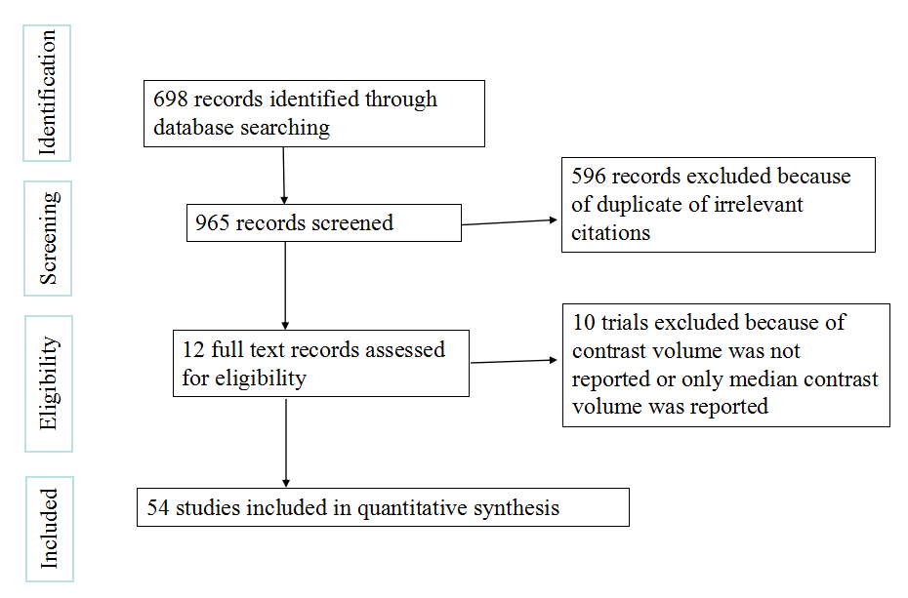  A | 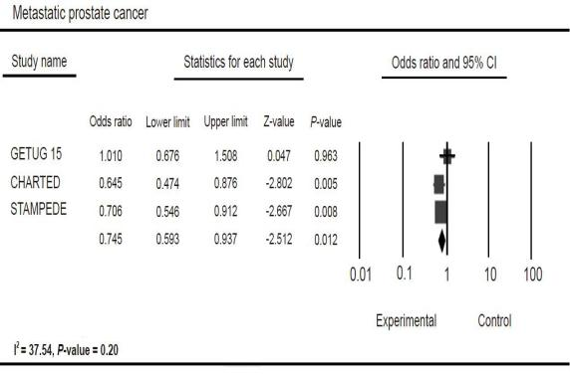  B
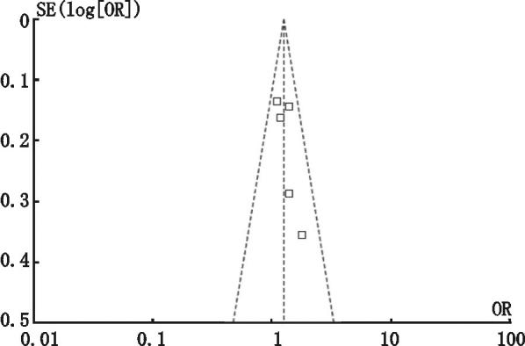
C
Figure 1. We present examples of flow diagram, forest plot and funnel plot in Figure 1A-C. A: description of what the Figure 1A is; B: description of what the Figure 1B is; C: description of what the Figure 1C is. CI: confidence interval; SE: standard error; OR: odds ratio. This figure is quoted with permission from XX et al.^{[2]}
Figure notes:
- It’s highly recommended that authors provide figures in format of TIFF, PSD, AI, or JPEG, with resolution 300-600 dpi.
- Figures should be clearly displayed. Non-English words should be avoided.
- If there is a copyright issue, authors should obtain copyright permission for using it. For more details, see Author Statement.
- Authors should pay attention to the protection of patients’ rights, such as privacy and portrait, and obtain signed patient consent from authors before using any personal information of patients. The patient’s portrait with full characters and his/her real name is not allowed for use.
DISCUSSION
In this part, authors should discuss the significance of the study, emphasize its value and state expectation on future studies that may need to be carried out. In details, it may include summary of key findings, strengths and limitations of the study, controversies raised by this study, and future research directions, etc.
Tips:
- Avoid redundant explanations to data or other materials given in the Introduction or the Results section.
- Contributors should avoid making statements on economic benefits and costs except for economic data and analyses that serve as an integral part of the manuscript.
DECLARATIONS
Acknowledgments (optional)
If there are contributions that need acknowledging but do not justify authorship, such as general support by a departmental chair, technical help, etc., please state in this part; if there is not, this subsection could be deleted.
Authors’ contributions
Single author:
Author (Surname + initial of Forename) solely responsible for the paper.
Two or more authors:
Design: Author 1 (Surname + initial of Forename)
Literature research: Author 2 (Surname + initial of Forename), Author 3 (…)
Data analysis: Author 3 (…)
Manuscript writing: …
Manuscript editing: …
Manuscript revision: …
…
Data source and availability
Authors should declare the data source and whether or how it could be available if requested here.
Financial support and sponsorship
If there are grants
This work was supported by Grant name XX (No. XXX; No. XXX)...
If there is no grant:
None.
Conflicts of interest
If there are any potential conflicts of interest about the manuscript version, authorship, or others, please declare here.
If not, please write as “There are no conflicts of interest”.
Patient consent
If there is patient related, please write as “Written consent form was obtained from the patient (or guardian)”.
If not, please write as “Not applicable”.
Ethics approval
If there are ethical issues related, please write as “This study was approved by the institutional review board of xxx (institution name)”.
If not, please write as “Not applicable”.
Copyright
© The Author(s) 2021.
REFERENCES
References should be numbered in order of appearance at the end of manuscripts. In the text, reference numbers should be placed in square brackets and the corresponding references are cited thereafter. Only the first five authors' names are required to be listed in the references, other authors’ names should be omitted and replaced with "et al.". Abbreviations of the journals should be provided on the basis of Index Medicus. Information from manuscripts accepted but not published should be cited in the text as "Unpublished material" with written permission from the source. The names of journals should be italicized.
References should be described as follows, depending on the types of works:
Types | Examples
Journal articles by individual authors | Weaver DL, Ashikaga T, Krag DN, Skelly JM, Anderson SJ, et al. Effect of occult metastases on survival in node-negative breast cancer. N Engl J Med 2011;364:412-21. [PMID: 21247310 DOI: 10.1056/NEJMoa1008108]
Organization as author | Diabetes Prevention Program Research Group. Hypertension, insulin, and proinsulin in participants with impaired glucose tolerance. Hypertension 2002;40:679-86. [PMID: 12411462]
Both personal authors and organization as author | Vallancien G, Emberton M, Harving N, van Moorselaar RJ; Alf-One Study Group. Sexual dysfunction in 1,274 European men suffering from lower urinary tract symptoms. J Urol 2003;169(6):2257-61. [PMID: 12771764 DOI: 10.1097/01.ju.0000067940.76090.73]
Journal articles not in English | Zhang X, Xiong H, Ji TY, Zhang YH, Wang Y. Case report of anti-N-methyl-D-aspartate receptor encephalitis in child. J Appl Clin Pediatr 2012;27:1903-7. (in Chinese)
Journal articles ahead of print | Odibo AO. Falling stillbirth and neonatal mortality rates in twin gestation: not a reason for complacency. BJOG 2018; Epub ahead of print [PMID: 30461178 DOI: 10.1111/1471-0528.15541]
Books | Sherlock S, Dooley J. Diseases of the liver and billiary system. 9th ed. Oxford: Blackwell Sci Pub; 1993. pp. 258-96.
Book chapters | Meltzer PS, Kallioniemi A, Trent JM. Chromosome alterations in human solid tumors. In: Vogelstein B, Kinzler KW, editors. The genetic basis of human cancer. New York: McGraw-Hill; 2002. pp. 93-113.
Online resource | FDA News Release. FDA approval brings first gene therapy to the United States. Available from: https://www.fda.gov/NewsEvents/Newsroom/PressAnnouncements/ucm574058.htm. [Last accessed on 30 Oct 2017]
Conference proceedings | Harnden P, Joffe JK, Jones WG, editors. Germ cell tumours V. Proceedings of the 5th Germ Cell Tumour Conference; 2001 Sep 13-15; Leeds, UK. New York: Springer; 2002.
Conference paper | Christensen S, Oppacher F. An analysis of Koza's computational effort statistic for genetic programming. In: Foster JA, Lutton E, Miller J, Ryan C, Tettamanzi AG, editors. Genetic programming. EuroGP 2002: Proceedings of the 5th European Conference on Genetic Programming; 2002 Apr 3-5; Kinsdale, Ireland. Berlin: Springer; 2002. pp. 182-91.
Unpublished material | Tian D, Araki H, Stahl E, Bergelson J, Kreitman M. Signature of balancing selection in Arabidopsis. Proc Natl Acad Sci U S A. Forthcoming 2002.
For other types of references, please refer to U.S. National Library of Medicine.
The journal also recommends that authors prepare references with a bibliography software package, such as EndNote to avoid typing mistakes and duplicated references.

