Original Article
Title: concisely convey the main topic(s) of the research
[Suggestions: No more than 16 words. No abbreviations except for standardized ones.]
Forename Surname¹, Forename Surname^{1,2}, Forename Surname³
¹Department, Institution, City Postcode, Country.
²Department, Institution, City, State Postcode, Country.
³Department, Institution, City Postcode, Province, Country.
Correspondence to: Prof./Dr. Forename Surname, Department, Institution, Detailed Address, City Postcode, Country. E-mail: xxxx@xxxx.xxx; ORCID: xxxx
Received: date month year
[e.g., 1 Jan 2020]
How to Use This Template
This template shows the manuscript structure that can be used in an original article: Abstract, Keywords, Introduction, Methods, Results, Discussion, Declarations and References. Please note that each part has a corresponding style, which authors should follow. Please note that the fonts in gray show writing requirements. For any questions, you may contact the editorial@jsssjournal.com.
Abstract
[Suggestions: No more than 250 words. No citations. Define abbreviations at their first mention.]
The abstract should state briefly the purpose of the research, the principal results and major conclusions. Unstructured.
Keywords: Data mining, cryptographic protocols, data anonymization, resilience, deep learning, cost function, clould computing
[Please suggest 3-8 keywords which can be used for describing the content of the manuscript and will enable the full text of the manuscript to be searchable online.]
- INTRODUCTION
The introduction is a beginning section of a manuscript which states the purpose of the study, overviews or summarizes previous findings and progress related to this study, and indicates its significance in this research field. It is generally followed by the body and discussion.
- METHODS
In this section, we suggest that authors may set headings and provide all the details of how you conducted your study and what you did for it. In detail, it may contain description of participants selection, materials, software, experimental apparatus (state the manufacturer’s name and address in parentheses), experiment object (human or animals), methods, procedures, technical information, necessary statistics, etc. All the information should be given in sufficient detail so that other scholars are able to reproduce the results.
2.1. Level 2 heading
[e.g., Statistical analyses]
2.1.1 Level 3 heading
[e.g., Data distributions, outliers and linear regression]
- RESULTS
This section shows the main findings of your study. It may contain conclusive description, analysis, and comparison with other related research results, etc. Authors may set headings to separate the results of different experiments in this section. Table 1 (other forms: Tables 1 and 2; Tables 1-3), Equation (1) [other forms: Equations (2) and (3); Equations (4-6)] and Figure 1 (other forms: Figure 1A and B; Figure 2A-C; Figures 1 and 2A; Figures 1, 2A and 3-5) show the examples of diagrams. All the tables, equations and figures should be cited in sequence in the main content near to the first time they appear. For supplementary material, authors may cite table, equation and figure like Supplementary Table 1, Supplementary Equation (1) and Supplementary Figure 1. For details, you may refer to Supplementary Material Template.
Tips:
- Results should be presented in a logical sequence;
- Avoid redundant explanations to all the data from the tables or illustrations.
Table 1. This is a table caption. A summary description of this table should be written here
Tag type | NDEF | Secure messaging | SDM | Random ID | Digital Sig. | Authentication | Memory access protection
NT4H2421Gx  NTAG21x  NTAG210μ | ✔  ✔  ✘ | ✔  ✘  ✘ | ✔  ✘  ✘ | ✔  ✘  ✘ | ✔  ✔  ✔ | ✔  ✘  ✘ | ✔  ✔  ✘
This table is cited with permission from XXX et al.^{[1]} published in xxx
Table notes:
- Tables should be cited in numeric order and placed after the paragraph where it is first cited;
- The table caption should be placed above the table and labeled sequentially (e.g., Table 1, Table 2);
- Tables should be provided in editable form like DOC or DOCX format (picture is not allowed);
- Abbreviations and symbols used in table should be explained in footnote;
- Explanatory matter should also be placed in footnotes;
- Non-English words should be avoided;
- Permission for use of copyrighted materials from other sources, including re-published, adapted, modified, or partial tables from the internet, must be obtained. It is authors’ responsibility to acquire the licenses, to follow any citation instruction requested by third-party rights holders, and cover any supplementary charges.
(1)
Equation note:
- Equations should be provided in editable form (image file format is not allowed).
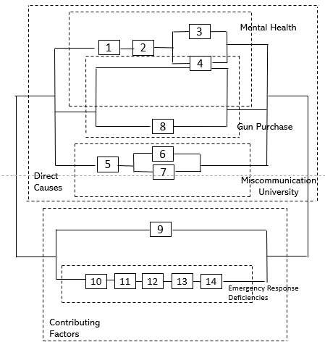  A | 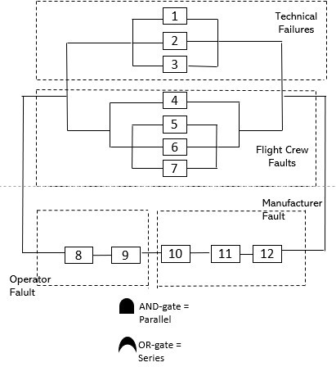  B
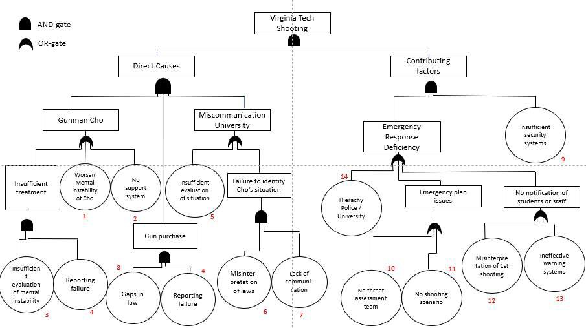
C
Figure 1. We present examples of a Reliability Block Diagram of Air XXX airplane crash in Figure 1A-C. A: description of what the Figure 1A is; B: description of what the Figure 1B is; C: description of what the Figure 1C is. This figure is quoted with permission from XX et al.^{[2]}
Figure notes:
- Figures should be cited in numeric order (e.g., Figure 1, Figure 2) and placed after the paragraph where it is first cited;
- Figures can be submitted in format of tiff, psd, AI or jpeg, with resolution of 300-600 dpi;
- Diagrams with describing words (including, flow chart, coordinate diagram, bar chart, line chart, and scatter diagram, etc.) should be editable in word, excel or powerpoint format. Non-English information should be avoided;
- Labels, numbers, letters, arrows, and symbols in figure should be clear, of uniform size, and contrast with the background;
- Symbols, arrows, numbers, or letters used to identify parts of the illustrations must be identified and explained in the legend;
- Internal scale (magnification) should be explained and the staining method in photomicrographs should be identified;
- All non-standard abbreviations should be explained in the legend;
- Authors should pay attention to the protection of patients’ rights, such as privacy and portrait, and obtain signed patient consent from authors before using any personal information of patients. The patient’s portrait with full characters and his/her real name is not allowed for use;
- Permission for use of copyrighted materials from other sources, including re-published, adapted, modified, or partial figures and images from the internet, must be obtained. It is authors’ responsibility to acquire the licenses, to follow any citation instruction requested by third-party rights holders, and cover any supplementary charges.
- DISCUSSION
In this part, authors should discuss the significance of the study, emphasize its value and state expectation on future studies that may need to be carried out. In details, it may include summary of key findings, strengths and limitations of the study, controversies raised by this study, and future research directions, etc.
Tips:
- Avoid redundant explanations to data or other materials given in the Introduction or the Results section;
- Contributors should avoid making statements on economic benefits and costs except for economic data and analyses that serve as an integral part of the manuscript.
- CONCLUSIONS
This section is not mandatory, but can be added to the manuscript if the discussion is unusually long or complex.
- PATENTS
This section is not mandatory, but may be added if there are patents resulting from the work reported in this manuscript.
DECLARATIONS
Acknowledgments
Anyone who contributed towards the article but does not meet the criteria for authorship, including those who provided professional writing services or materials, should be acknowledged. Authors should obtain permission to acknowledge from all those mentioned in the Acknowledgments section. This section is not added if the author does not have anyone to acknowledge.
Authors’ contributions
Single author:
The author contributed solely to the article.
Two or more authors:
Made substantial contributions to conception and design of the study and performed data analysis and interpretation: Salas H, Castaneda WV;
Performed data acquisition, as well as provided administrative, technical, and material support: Castillo N, Young V

Availability of data and materials
Authors should declare where the data supporting their findings can be found. Data can be deposited into data repositories or published as supplementary information in the journal. Authors who cannot share their data should state that the data will not be shared and explain it.
If a manuscript does not involve such issue, please state “Not applicable.” in this section.
Financial support and sponsorship
If there are sources of funding for the study reported, any relevant grant numbers and the link of funder’s website should be provided if any. The role of the funding body in the experiment design, collection, analysis and interpretation of data, and writing of the manuscript should be declared:
This work was supported by Grant name XX (No. XXXX; No. XXX)...
If there is no grant:
None.
Conflicts of interest
If there are any potential conflicts of interest that may be perceived as inappropriately influencing the representation or interpretation of reported research results, please declare here.
If not, please write as “All authors declared that there are no conflicts of interest.”.
Some authors may be bound by confidentiality agreements. In such cases, in place of itemized disclosures, we will require authors to state “All authors declare that they are bound by confidentiality agreements that prevent them from disclosing their conflicts of interest in this work.”.
If authors are unsure whether conflicts of interest exist, please refer to the “Conflicts of Interest” of JSSS Editorial Policies for a full explanation.
Ethical approval and consent to participate
Research involving human subjects, human material or human data must be performed in accordance with the Declaration of Helsinki and approved by an appropriate ethics committee. An informed consent to participate in the study should also be obtained from participants, or their parents or legal guardians for children under 16. A statement detailing the name of the ethics committee (including the reference number where appropriate) and the informed consent obtained must appear in the manuscripts reporting such research.
If the manuscript does not involve such issue, please state “Not applicable.” in this section.
Consent for publication
Manuscripts containing individual details, images or videos, must obtain consent for publication from that person, or in the case of children, their parents or legal guardians. If the person has died, consent for publication must be obtained from the next of kin of the participant. Manuscripts must include a statement that a written informed consent for publication was obtained. Authors do not have to submit such content accompanying the manuscript. However, these documents must be available if requested.
If the manuscript does not involve this issue, state “Not applicable.” in this section.
Copyright
© The Author(s) 2020.
REFERENCES
Authors should cite references in sequence throughout the manuscript and indicate them in a superscript square bracket with one citation number^{[3]}, two separate citation numbers^{[4,5]} or several consecutive citation numbers^{[6-9]}.
- We suggest that authors should cite appropriate, traceable and latest references be within recent 5 years;
- Each reference should have a corresponding DOI number/website link;
- Top five authors’ names should be listed in the references;
- The names of journals should be abbreviated according to the style used in Index Medicus (http://www2.bg.am.poznan.pl/czasopisma/medicus.php?lang=eng).
Examples of references are shown below:
Journal articles by individual authors
Weaver, D. L.; Ashikaga, T.; Krag, D. N. Effect of occult metastases on survival in node-negative breast cancer. N. Engl. J. Med. 2011, 364, 412-421. DOI: 10.1056/NEJMoa1008108

Organization as author
Diabetes Prevention Program Research Group. Hypertension, insulin, and proinsulin in participants with impaired glucose tolerance. Hypertension 2002, 40, 679-686. DOI: 10.1161/01.HYP.0000035706.28494.09

Both personal authors and organization as author
Vallancien, G.; Emberton, M.; Harving, N.; van Moorselaar, R. J.; Alf-One Study Group. Sexual dysfunction in 1,274 European men suffering from lower urinary tract symptoms. J. Urol. 2003, 169, 2257-2261. DOI: 10.1097/01.ju.0000067940.76090.73

Journal articles not in English
Zhang X.; Xiong H.; Ji T. Y.; Zhang Y. H.; Wang Y. Case report of anti-N-methyl-D-aspartate receptor encephalitis in child. J. Appl. Clin. Pediatr. 2012, 27, 1903-1907. (in Chinese)

Journal articles ahead of print
Odibo, A. O. Falling stillbirth and neonatal mortality rates in twin gestation: not a reason for complacency. BJOG. 2018, Epub ahead of print [DOI: 10.1111/1471-0528.15541]

ebook
Hammond, C. The Basics of Crystallography and Diffraction, 4th ed.; Oxford University Press, 2015. DOI: 10.1093/acprof:oso/9780198738671.001.0001

Book in print
Frankel, F. Picturing Science and Engineering; MIT Press, 2018.

ebook chapter
Hammond, C. Crystal Symmetry. In The Basics of Crystallography and Diffraction, 4th ed.; International Union of Crystallography Texts on Crystallography, Vol. 21; Oxford University Press, 2015; pp 99−134. DOI: 10.1093/acprof:oso/9780198738671.003.0004

ebook with editors
Mom the Chemistry Professor: Personal Accounts and Advice from Chemistry Professors Who Are Mothers, 2nd ed.; Woznack, K., Charlebois, A., Cole, R. S., Marzabadi, C. H., Webster, G., Eds.; Springer, 2018. DOI: 10.1007/978-3-319-78972-9

ebook series
Gaede, H. C. Professional Development for REU Students. In Best Practices for Chemistry REU Programs; Griep, M. A, Watkins, L., Eds.; ACS Symposium Series, Vol. 1295; American Chemical Society, 2018; pp 33−44. DOI: 10.1021/bk-2018-1295.ch003

Thesis or dissertation
Cable, M. L. Life in Extreme Environments: Lanthanide-Based Detection of Bacterial Spores and Other Sensor Design Pursuits. Ph.D. Dissertation, California Institute of Technology, Pasadena, CA, 2010. http://resolver.caltech.edu/CaltechTHESIS:05102010-145436548 (accessed 2019-09-10).

Thesis or dissertation in print
Enander, R. T. Lead particulate and methylene chloride risks in automotive refinishing. Ph.D. Thesis, Tufts University, Medford, MA, 2001.

Website
World Health Organization Home Page. https://www.who.int/ (accessed 2019-02-21).

Newspaper
Beauge, J. School district sued over burns girl suffered during chemistry class demonstration. PennLive (Harrisburg, PA), November 17, 2018, updated November 17, 2018. https://www.pennlive.com/news/2018/11/school_district_sued_over_burn.html (accessed 2019-02-22).

Conference abstract
Okita, J.; Iwamoto, T.; Kira, M. Novel synthetic route for hydrosilyllithiums. In Book of Abstracts, 2000 International Chemical Congress of Pacific Basin Societies (PACIFICHEM 2000), Honolulu, HI; Paper INOR 216.

Conference proceedings
Nilsson, A.; Petersson, F.; Persson, H. W.; Jönsson, H.; Laurell, T. Manipulation of suspended particles in a laminar flow. In Micro Total Analysis Systems 2002, Proceedings of the μTAS 2002 Symposium, Nara, Japan, November 3−7, 2002; Baba, Y., Shoji, S., van den Berg, A., Eds.; Kluwer Academic Publishers: Dordrecht, The Netherlands, 2002; Vol. 2, pp 751−753. DOI: 10.1007/978-94-010-0504-3_50

Database
SpectraBase. Bio-Rad Laboratories. https://spectrabase.com/ (accessed 2020-01-05).

Patent
Stern, M. K.; Cheng, B. K. M. Process for preparing N-(p-nitroaryl)amides via reaction of nitrobenzene with nitriles. US 5380946, 1995.

Preprint
Yamamoto T. S.; Inui R.; Tada Y.; Yokoyama S. Prospects of detection of subsolar mass primordial black hole and white dwarf binary mergers. arXiv 2004, arXiv:2401.00044. Available online: https://arxiv.org/abs/2401.00044 (accessed 29 December 2023).

