Correction/Erratum/Retraction

Correction/Erratum/Retraction: Title of the corresponding published paper (Chem Synth Year; doi number)
[Suggestions: No more than 16 words. Titles are often used in information-retrieval systems. Avoid abbreviations and formulae where possible.]

Forename Surname¹, Forename Surname^{1,2}, Forename Surname³

¹Department, Institution, City Postcode, Country.
²Department, Institution, City, State Postcode, Country.
³Department, Institution, City Postcode, Province, Country.

Correspondence to: Prof./Dr. Forename Surname, Department, Institution, Detailed Address, City Postcode, Country. E-mail: xxxx@xxxx.xxx; ORCID: xxxx

Received: date month year
[e.g., 1 Jan 2025]

How to Use This Template
This template shows the manuscript structure that can be used in a correction/erratum/retraction. Please note that each part has a corresponding style, which authors should follow. Please note that the fonts in gray show writing requirements. For any questions, you may contact the editorial office.

MAIN TEXT
In this part, authors may provide a brief explanation on the reason why they publish this paper. For Correction/Erratum, authors should also show which part did they correct, and specify the correct content/illustration, etc. Table 1, Equation (1) and Figure 1 show the examples of diagrams.

Table 1. This is a table caption. A summary description of this table should be written here
Authors | Regimen | n | Age (year) | CR (%) | 2-year (3-year) EFS/PFS (%) | 2-year (3-year) OS (%)
Our current study | CHOP  CVP | 251  67 | 17-82  45-87 | 69.8  29.9* | 55.3 (46.0)  18.0 (12.0)* | 58.0 (52.0)  25.0 (19.0)*
Khaled et al.^{[1]} | CHOP | 40 | 19-75 | 67 | 54 (54) | 82 (71)
Burton et al.^{[2]} | CHOP  CIOP | 105  106 | 22-66  25-67 | 70  52 | 4-year PFS: 56  4-year PFS: 40* | 4-year OS: 65  4-year OS: 56#
This part is footer. *P < 0.05, #P ≥ 0.05. EFS: event-free survival; PFS: progression-free survival; OS: overall survival; CHOP: cyclophosphamide, doxorubicin, vincristine, and prednisone; CVP: cyclophosphamide, vincristine, and prednisone; CIOP: cyclophosphamide, idarubicin, vincristine, and prednisone; CR: complete response. This table is cited with permission from Li et al.^{[1]} published in xxx
Table notes:
- Tables should be cited in numeric order and placed after the paragraph where it is first cited;
- The table caption should be placed above the table and labeled sequentially (e.g., Table 1, Table 2).
- Tables should be provided in editable form like DOC or DOCX format (picture is not allowed);
- Abbreviations and symbols used in table should be explained in footnote;
- Explanatory matter should also be placed in footnotes;
- Non-English words should be avoided;
- Permission for use of copyrighted materials from other sources, including re-published, adapted, modified, or partial tables from the internet, must be obtained. It is authors’ responsibility to acquire the licenses, to follow any citation instruction requested by third-party rights holders, and cover any supplementary charges.
(1)
Equation note:
- Equations should be provided in editable form (image file format is not allowed).
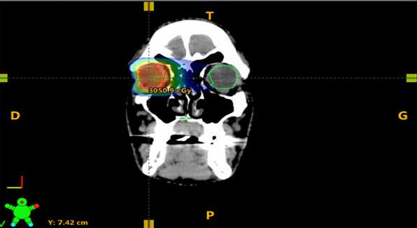  A | 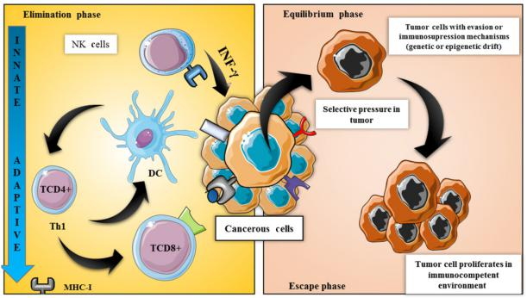  B
C
Figure 1. We present examples of electron micrograph, non-editable and editable images in Figure 1A-C. A: description of what the Supplementary Figure 1A is; B: description of what the Figure 1B is; C: description of what the Figure 1C is. This figure is quoted with permission from XX et al.^{[1]}
Figure notes:
- Figures should be cited in numeric order (e.g., Figure 1, Figure 2) and placed after the paragraph where it is first cited;
- Figures can be submitted in format of tiff, psd, AI or jpeg, with resolution of 300-600 dpi;
- Diagrams with describing words (including, flow chart, coordinate diagram, bar chart, line chart, and scatter diagram, etc.) should be editable in word, excel or powerpoint format. Non-English information should be avoided;
- Labels, numbers, letters, arrows, and symbols in figure should be clear, of uniform size, and contrast with the background;
- Symbols, arrows, numbers, or letters used to identify parts of the illustrations must be identified and explained in the legend;
- Internal scale (magnification) should be explained and the staining method in photomicrographs should be identified;
- All non-standard abbreviations should be explained in the legend;
- Authors should pay attention to the protection of patients’ rights, such as privacy and portrait, and obtain signed patient consent from authors before using any personal information of patients. The patient’s portrait with full characters and his/her real name is not allowed for use;
- Permission for use of copyrighted materials from other sources, including re-published, adapted, modified, or partial figures and images from the internet, must be obtained. It is authors’ responsibility to acquire the licenses, to follow any citation instruction requested by third-party rights holders, and cover any supplementary charges.

REFERENCES
Authors should cite references in sequence throughout the manuscript and indicate them in a superscript square bracket with one citation number^{[3]}, two separate citation numbers^{[4,5]} or several consecutive citation numbers^{[6-9]}.
- We suggest that authors should cite appropriate, traceable and latest references be within recent 5 years;
- Each reference should have a corresponding DOI number/website link;
- If there are six authors or less, please list all the authors; If there are more than six authors, please list the first three authors with et al.;
- The names of journals should be abbreviated according to the style used in Index Medicus (http://www2.bg.am.poznan.pl/czasopisma/medicus.php?lang=eng). The names of journals should be Italic.
Examples of references are shown below:
Journal articles by individual authors
Weaver, D. L.; Ashikaga, T.; Krag, D. N. Effect of occult metastases on survival in node-negative breast cancer. N. Engl. J. Med. 2011, 364, 412-421. DOI: 10.1056/NEJMoa1008108

Organization as author
Diabetes Prevention Program Research Group. Hypertension, insulin, and proinsulin in participants with impaired glucose tolerance. Hypertension 2002, 40, 679-686. DOI: 10.1161/01.HYP.0000035706.28494.09

Both personal authors and organization as author
Vallancien, G.; Emberton, M.; Harving, N.; van Moorselaar, R. J.; Alf-One Study Group. Sexual dysfunction in 1,274 European men suffering from lower urinary tract symptoms. J. Urol. 2003, 169, 2257-2261. DOI: 10.1097/01.ju.0000067940.76090.73

Journal articles not in English
Zhang X.; Xiong H.; Ji T. Y.; Zhang Y. H.; Wang Y. Case report of anti-N-methyl-D-aspartate receptor encephalitis in child. J. Appl. Clin. Pediatr. 2012, 27, 1903-1907. (in Chinese)

Journal articles ahead of print
Odibo, A. O. Falling stillbirth and neonatal mortality rates in twin gestation: not a reason for complacency. BJOG. 2018, Epub ahead of print [DOI: 10.1111/1471-0528.15541]

ebook
Hammond, C. The Basics of Crystallography and Diffraction, 4th ed.; Oxford University Press, 2015. DOI: 10.1093/acprof:oso/9780198738671.001.0001

Book in print
Frankel, F. Picturing Science and Engineering; MIT Press, 2018.

ebook chapter
Hammond, C. Crystal Symmetry. In The Basics of Crystallography and Diffraction, 4th ed.; International Union of Crystallography Texts on Crystallography, Vol. 21; Oxford University Press, 2015; pp 99−134. DOI: 10.1093/acprof:oso/9780198738671.003.0004

ebook with editors
Mom the Chemistry Professor: Personal Accounts and Advice from Chemistry Professors Who Are Mothers, 2nd ed.; Woznack, K., Charlebois, A., Cole, R. S., Marzabadi, C. H., Webster, G., Eds.; Springer, 2018. DOI: 10.1007/978-3-319-78972-9

ebook series
Gaede, H. C. Professional Development for REU Students. In Best Practices for Chemistry REU Programs; Griep, M. A, Watkins, L., Eds.; ACS Symposium Series, Vol. 1295; American Chemical Society, 2018; pp 33−44. DOI: 10.1021/bk-2018-1295.ch003

Thesis or dissertation
Cable, M. L. Life in Extreme Environments: Lanthanide-Based Detection of Bacterial Spores and Other Sensor Design Pursuits. Ph.D. Dissertation, California Institute of Technology, Pasadena, CA, 2010. http://resolver.caltech.edu/CaltechTHESIS:05102010-145436548 (accessed 2019-09-10).

Thesis or dissertation in print
Enander, R. T. Lead particulate and methylene chloride risks in automotive refinishing. Ph.D. Thesis, Tufts University, Medford, MA, 2001.

Website
World Health Organization Home Page. https://www.who.int/ (accessed 2019-02-21).

Newspaper
Beauge, J. School district sued over burns girl suffered during chemistry class demonstration. PennLive (Harrisburg, PA), November 17, 2018, updated November 17, 2018. https://www.pennlive.com/news/2018/11/school_district_sued_over_burn.html (accessed 2019-02-22).

Conference abstract
Okita, J.; Iwamoto, T.; Kira, M. Novel synthetic route for hydrosilyllithiums. In Book of Abstracts, 2000 International Chemical Congress of Pacific Basin Societies (PACIFICHEM 2000), Honolulu, HI; Paper INOR 216.

Conference proceedings
Nilsson, A.; Petersson, F.; Persson, H. W.; Jönsson, H.; Laurell, T. Manipulation of suspended particles in a laminar flow. In Micro Total Analysis Systems 2002, Proceedings of the μTAS 2002 Symposium, Nara, Japan, November 3−7, 2002; Baba, Y., Shoji, S., van den Berg, A., Eds.; Kluwer Academic Publishers: Dordrecht, The Netherlands, 2002; Vol. 2, pp 751−753. DOI: 10.1007/978-94-010-0504-3_50

Database
SpectraBase. Bio-Rad Laboratories. https://spectrabase.com/ (accessed 2020-01-05).

Patent
Stern, M. K.; Cheng, B. K. M. Process for preparing N-(p-nitroaryl)amides via reaction of nitrobenzene with nitriles. US 5380946, 1995.

Preprint
Yamamoto T. S.; Inui R.; Tada Y.; Yokoyama S. Prospects of detection of subsolar mass primordial black hole and white dwarf binary mergers. arXiv 2004, arXiv:2401.00044. Available online: https://arxiv.org/abs/2401.00044 (accessed 29 December 2023).

