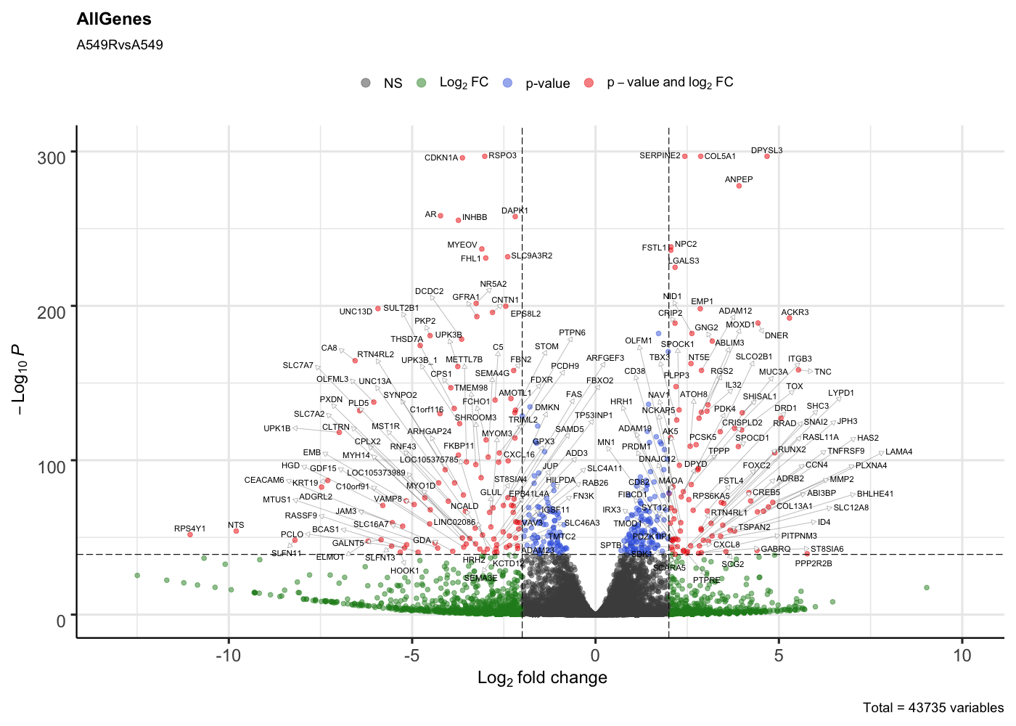
Supplementary Figure 1. Volcano plot of differentially expressed genes in nutlin-3 resistant A549.R2 cells versus parental A549 cells. Log2 fold change cutoff ≤ -2 / ≥ 2, P-value cutoff ≤ 10e-40

